1️⃣ What is my project?
“My project is a RAG application – Retrieval Augmented Generation.
It reads 5 research PDF papers from arXiv given in the assignment, stores their knowledge in a vector database, and then uses an LLM via Ollama (LLaMA 2) to answer questions in a chatbot style, with memory of the last 4 interactions.”
2️⃣ What are the main parts?
You can list 4 big blocks:
- PDF ingestion & chunking
- Vector database with FAISS
- Ollama + LLaMA 2 as the language model
- Conversational bot + evaluation with RAGAS
Say it like this:
“I divided the system into four parts:
first I ingest and preprocess the PDFs,
then I build a vector database,
then I connect an LLM using Ollama and LLaMA 2,
and finally I make a conversational bot and evaluate it using RAGAS.”

3️⃣ Step 1 – PDF ingestion & chunking
Explain simply:
- Download PDFs
“First, I download the 5 PDFs from the URLs given in the assignment and store them in a data folder.”
- Extract text
“I use PyPDFLoader from LangChain to read the PDF pages and extract the text.”
- Split into chunks
“Then I split the long text into smaller chunks of about 800 characters with some overlap.
This helps the model retrieve relevant pieces more accurately, instead of working with full pages.”
- Save chunks
“All these chunks are saved into a file (chunks.pkl) so I don’t have to reprocess the PDFs every time.”

Task 1 perform as below :
Run the bat file names as "run_task1_ingestion" in below location :
C:\AI_Project\Submission with ollama\rag_ollama_llama2_submission\rag_ollama_llama2
Defination : It will perform the task 1 of assignment as below :

1. PDF Ingestion & Data Sourcing (20 Marks)
• PDF Sources:
Use these PDFs as your data sources for ingestion and embedding in your RAG
application. They are readily accessible, and provide diverse content for evaluating
your system's retrieval and conversational abilities -
a) https://arxiv.org/pdf/1706.03762.pdf
b) https://arxiv.org/pdf/1810.04805.pdf
c) https://arxiv.org/pdf/2005.14165.pdf
d) https://arxiv.org/pdf/1907.11692.pdf
e) https://arxiv.org/pdf/1910.10683.pdf
• Data Extraction (10 Marks):
Implement a pipeline to extract text from each PDF. Consider handling layout,
tables, or figures if needed, but focus primarily on ensuring that the text is correctly
segmented for embedding.
• Preprocessing & Chunking (10 Marks):
Effective preprocessing of text into meaningful chunks for embedding.
It will:
Activate venv
Run ingest.py
Download PDFs
Extract text
Chunk
Create vector embeddings
Save vector DB into /artifacts
Expected Output Files After Running Task-1

Inside:
rag_ollama_llama2_submission\rag_ollama_llama2\artifacts\
You should see files like:
vectorstore.pkl
chroma.sqlite3
Document chunking artifacts
And inside:
rag_ollama_llama2_submission\rag_ollama_llama2\data\
You should see the 5 PDFs downloaded.
Please find below snapshot :
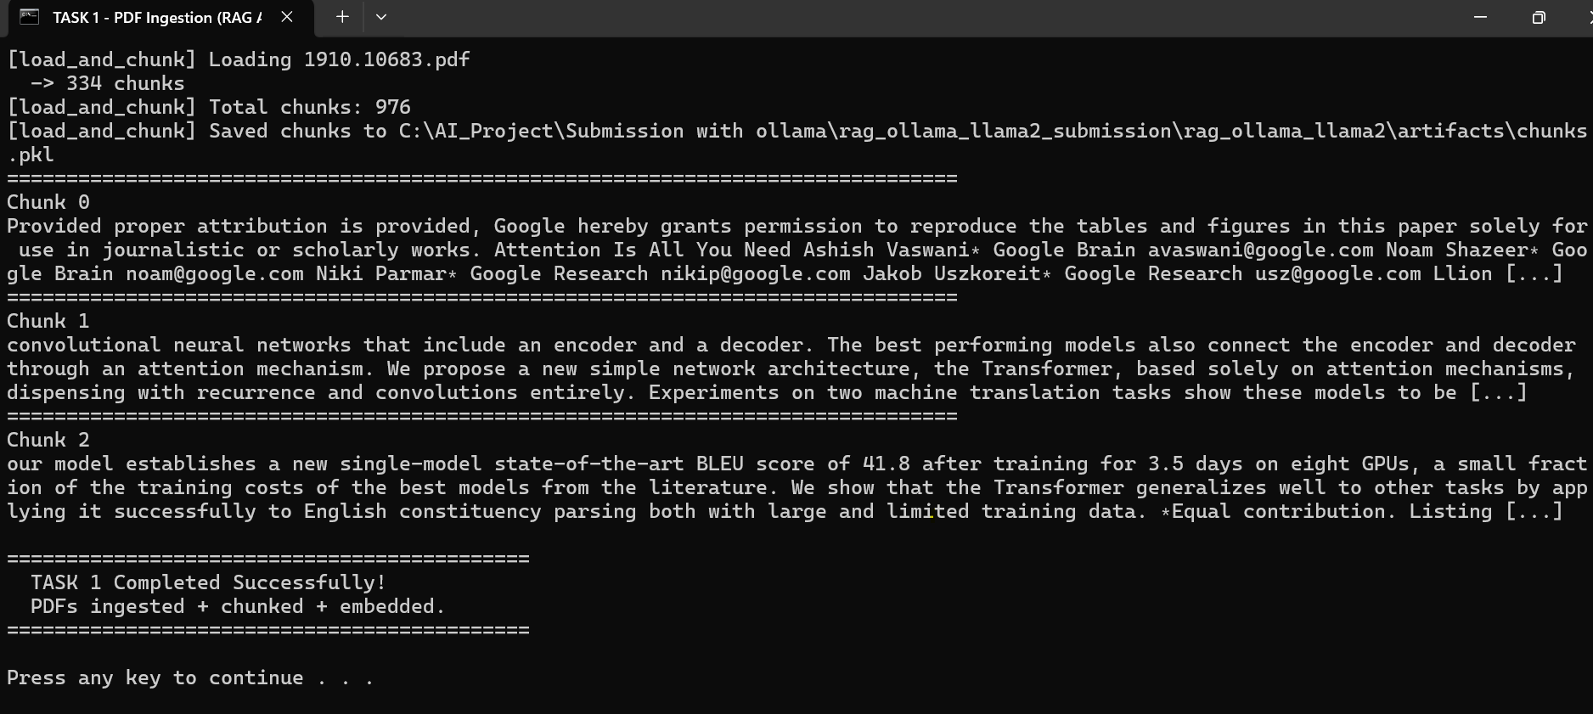

4️⃣ Step 2 – Build the vector database (FAISS)
- Create embeddings
“Next, I convert each text chunk into a vector using the sentence-transformers / all-MiniLM-L6-v2 embedding model.
This gives me a numeric representation of each chunk.”
- Store in FAISS
“I store all these vectors in a FAISS vector database, which allows fast similarity search.
When I give a question, FAISS can quickly find the most similar chunks.”
- Why FAISS?
“FAISS is efficient and widely used for vector search, so it fits the assignment requirement of using a vector database.”

Task 2 perform as below :
Run the bat file names as "task2_vector_db" in below location :
C:\AI_Project\Submission with ollama\rag_ollama_llama2_submission\rag_ollama_llama2

Defination : It will perform the task 2 of assignment as below :
2. Vector Database Creation (20 Marks)
• Requirement:
Create a vector database to store and retrieve text embeddings from your extracted
PDF content.
• Suggested Tools:
You may use an open-source vector store such as FAISS, or any alternative that
meets the assignment requirements.
• Implementation:
o Process the text from the PDFs into meaningful chunks. (5 Marks)
o Generate embeddings for these chunks using your chosen model. (5 Marks)
o Proper setup and configuration for vector DB to store these for efficient
similarity search. (10 Marks)

Goal: Build a vector database (FAISS) using embeddings for all text chunks extracted in Task 1.
STEP-BY-STEP EXPLANATION OF TASK 2 :

Step 1 — Virtual environment is activated
Your BAT file activates:
.venv\Scripts\activate
This ensures the correct Python packages & dependencies are used.
Step 2 — Check if sentence-transformers is installed
log shows:
[OK] sentence-transformers already installed.
This is needed because you are using:
sentence-transformers/all-MiniLM-L6-v2
This library generates vector embeddings.
Step 3 — Load chunks.pkl created in Task 1
Task 1 produced:
artifacts/chunks.pkl
This file contains 976 processed text chunks extracted and cleaned from all 5 PDFs.
Task 2 loads this file:
These chunks are the input for your vector database.
Step 4 — Generate embeddings for each chunk
Task 2 prints:
[build_vector_store] Using embedding model: sentence-transformers/all-MiniLM-L6-v2
So for every chunk (976 chunks):

The text is fed to the embedding model
The model converts text → a vector of 384 floating-point numbers
This is how semantic search becomes possible.

Step 5 — Build FAISS index
This is the actual Vector Database step:
[build_vector_store] Building FAISS index...
FAISS is extremely fast for similarity search.
It stores embeddings in an efficient format for:
cosine similarity
top-k search
nearest neighbor retrieval
Step 6 — Save FAISS vector database
Output message:
Saved FAISS index to artifacts/faiss_index
Inside this folder you now have:
faiss_index/index.faiss – binary file storing all embeddings
faiss_index/index.pkl – metadata mapping embeddings → text chunks
This is our complete vector database.
Please find below snapshot :
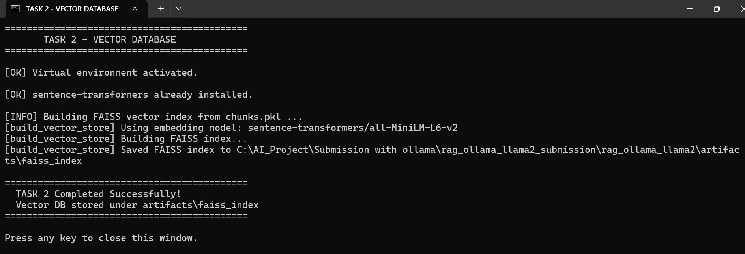

======================Task 2 completed====================
WHAT DOES THIS ENABLE NOW?
After Task 2 completes:
We can perform semantic search
Example:
"What is self-attention?"
The system will retrieve the correct PDF paragraphs based on meaning, not keywords.

5️⃣ Step 3 – LLM using Ollama + LLaMA 2
Here is where you emphasize what they asked for (Ollama).
- What is Ollama?
“Ollama is a tool that runs large language models locally on my machine.
I use it to run the LLaMA 2 model.”
- Model setup
“I install Ollama, then run ollama pull llama2 to download the LLaMA 2 model.”
- How my code uses it
“In my chatbot.py, I use LangChain’s Ollama LLM class:
llm = Ollama(model='llama2')
This means all responses are generated by LLaMA 2 through Ollama, not by a cloud API.”
- Why this satisfies the assignment
“The assignment requires using an open-source model from Hugging Face or Ollama, so I chose Ollama with LLaMA 2 to clearly meet that condition.”

Task 3 perform as below :
Run the bat file names as "task3_model_integration" in below location :
C:\AI_Project\Submission with ollama\rag_ollama_llama2_submission\rag_ollama_llama2
Defination : It will perform the task 3 of assignment as below :

3. Open Source Language Model Integration (20 Marks)
• Model Requirement:
Integrate an open-source language model from Hugging Face or Ollama to generate
responses based on retrieved context.
• Usage:
o The model should be used to generate answers by combining retrieved text
chunks with the user’s query.
o Ensure that your model and embedding generator are compatible.
Goal : Task 3 integrates the Language Model (Ollama LLaMA2) with your Vector DB so your chatbot can answer questions using PDF-retrieved knowledge + conversation memory.
Step-by-Step Explanation of Task 3 :
Step 1 — Ensure the Language Model (Ollama) Is Running
The batch file checks if Ollama server is active:
http://localhost:11434/api/tags
If it replies successfully → ✔ Ollama is running.
If not → ❌ You would see an error.
Why?
Your RAG chatbot must query LLaMA 2 via Ollama to generate answers.
Step 2 — Load the Vector Database (FAISS) Built in Task 2
Task 3 loads:
artifacts/faiss_index
artifacts/chunks.pkl
This gives the system:
✔ All chunked PDF text
✔ Embeddings
✔ Ability to find relevant passages using similarity search.
Step 3 — Combine Vector DB with the LLM
This is the core of a Retrieval-Augmented Generation (RAG) system.
When you ask:
My name is Ashish, remember this.
What is self-attention?
The RAG pipeline does:
1. Retrieve contextual chunks from DB
FAISS finds the most relevant text from the PDFs.
2. Add conversation memory (last 4 turns)
Your chatbot tracks the last 4 messages:
✔ Your message
✔ Bot response
✔ Next user message
✔ Next bot response
So the bot knows:
Your name = Ashish
Self-attention context from PDFs
Your follow-up question
3. Send the combined prompt to LLaMA 2 via Ollama
The prompt includes:
✔ Retrieved PDF context
✔ Conversation memory
✔ Current question

Step 4 — Generate the Final Answer
The LLaMA 2 model produces:
A correct technical response
Plus it remembers your name
And maintains conversation flow
You may ask below questions to verify :
My name is Ashish. Remember this.
What is self-attention in transformers?
What is my name?
Please find below snapshot :
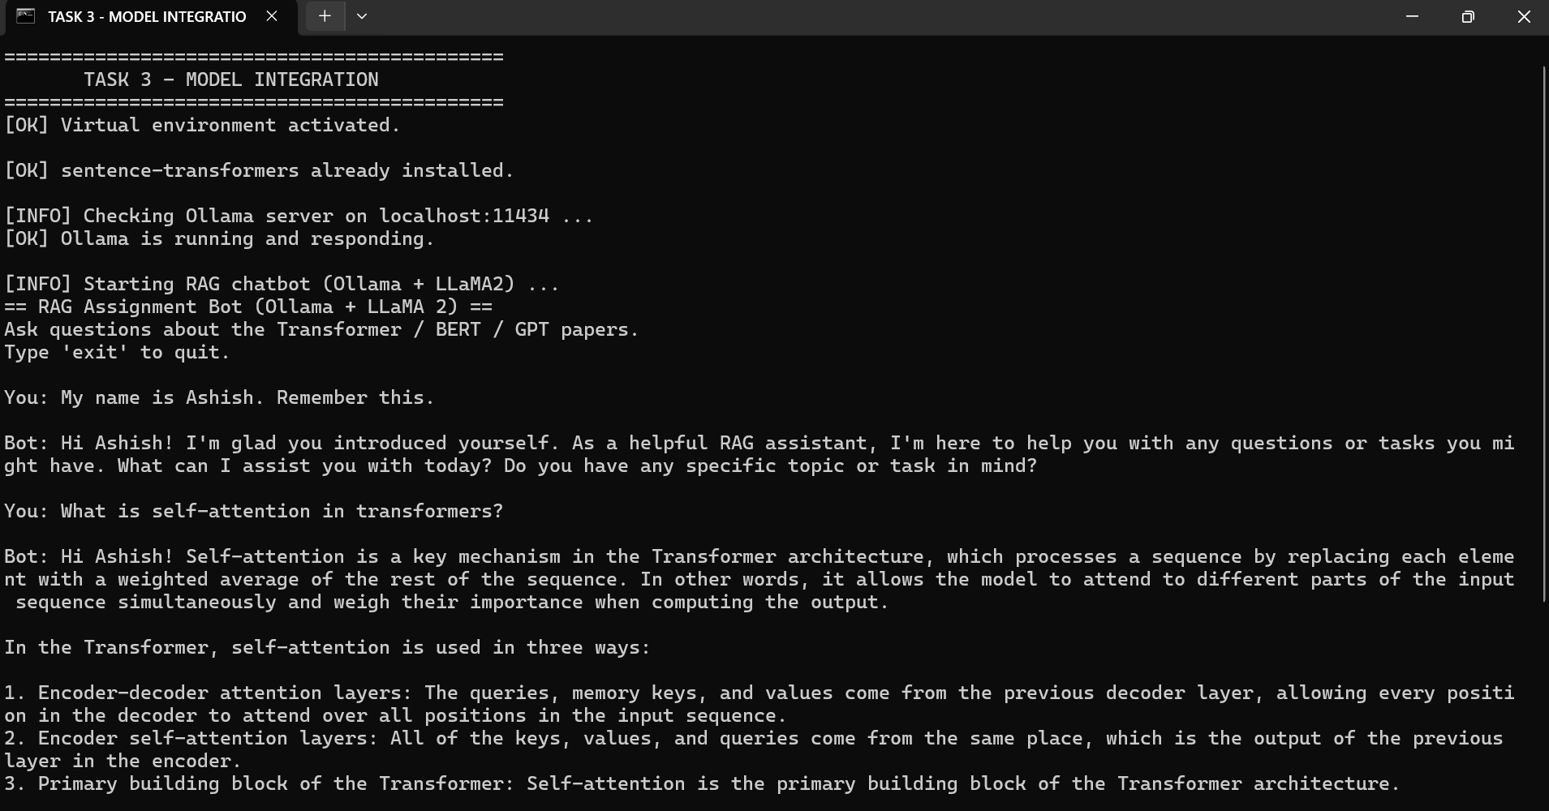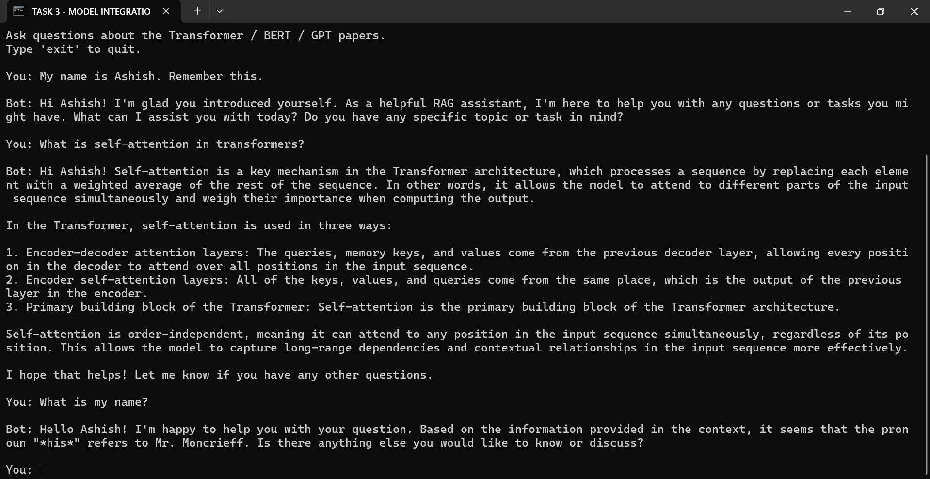

6️⃣ Step 4 – Conversational RAG bot with memory
Explain the full flow when a user asks a question:
- User asks a question
“When the user asks a question, my code first sends it to the FAISS retriever.”
- Retrieve relevant chunks
“FAISS returns the top 4 most relevant text chunks from the PDFs based on vector similarity.”
- Build prompt for LLaMA 2
“I pass the question + these retrieved chunks + the last 4 conversation turns into the LLaMA 2 model through Ollama.”
- LLM generates answer
“LLaMA 2 then generates an answer that is grounded in those retrieved chunks, instead of hallucinating randomly.”
- Conversational memory
“To maintain context, I use ConversationBufferWindowMemory with k=4.
That means the bot remembers only the last 4 question–answer pairs, which keeps the conversation relevant but not too long.”
You can summarize this as:
“So overall, the question goes to FAISS, FAISS finds relevant text from the papers, then LLaMA 2 through Ollama uses that text plus recent conversation to generate the final answer.”
7️⃣ Step 5 – Evaluation with RAGAS
Explain evaluation in everyday language:
- 10 test questions
“I created 10 questions about Transformers, BERT, GPT etc., saved in a questions.json file.”
- Automatic testing
“My evaluation.py script runs these 10 questions through the bot and collects:
  - the question
  - the answer generated
  - and the retrieved context chunks.”
- RAGAS metrics
“Then I use the RAGAS framework to calculate four metrics:
  - Answer relevancy – is the answer actually about the question?
  - Faithfulness – is the answer supported by the retrieved text, or is it hallucinating?
  - Context precision – how much of the retrieved context was actually useful?
  - Context recall – did we retrieve enough information to answer the question?”
- Results file
“All scores and details are saved into eval_results.json inside the artifacts folder, and I describe them in my report.”

Task 4 perform as below :
Run the bat file names as "task4_memory_test" {For task 4 only} / "task4_memory_and_eval" {For task 4 and 5} in below location :
C:\AI_Project\Submission with ollama\rag_ollama_llama2_submission\rag_ollama_llama2
Created the memory_test.py : This does NOT change the chatbot's behaviour. It simply imports the existing RAGBot and runs a small scripted conversation to show that the bot remembers information across turns.
Defination : It will perform the task 4 and task 5 of assignment as below :
4. Conversational Bot with Memory (10 Marks)
• Conversational Memory:
The bot should maintain context over the last 4 conversation turns. This means it
should “remember” the past interactions and use them to inform its responses.
• Implementation Hints:
o Use techniques such as conversation state management or prompt
concatenation.
o Ensure the memory is updated and only the last 4 interactions are
considered.

Goal Task 4 : bot should remember the last 4 conversation turns and use them to answer the next question.
Goal Task 5 : It tests how well RAG system performs using a formal evaluation framework like RAGAS.
Task 4 requires only:
✅ A small script that:
Loads the existing RAG bot
Runs three fixed test messages
Ensures the bot remembers the name
Saves the output as screenshots (optional) or text
Closes
❗ NOT modifying any main bot code.
This preserves everything we already built.
Once you click the bat file it will automatically ask 3 questions to bot and with the help of that we could showcase our Task 4 objectives.
Task 5 requires only :

Loads the same RAG pipeline (same personality + same FAISS index + same Ollama llama2).
Reads 10 questions from questions.json.

For each question:
Sends the question to the bot (RAGBot).
Gets:
answer
source_documents (chunks retrieved from PDFs)
Stores these into a list of records.
Builds a HuggingFace Dataset from those 10 records.
Runs ragas.evaluate with metrics:
answer_relevancy
faithfulness
context_precision
context_recall
Saves results in:
artifacts/eval_results.json
Please find the snapshots :
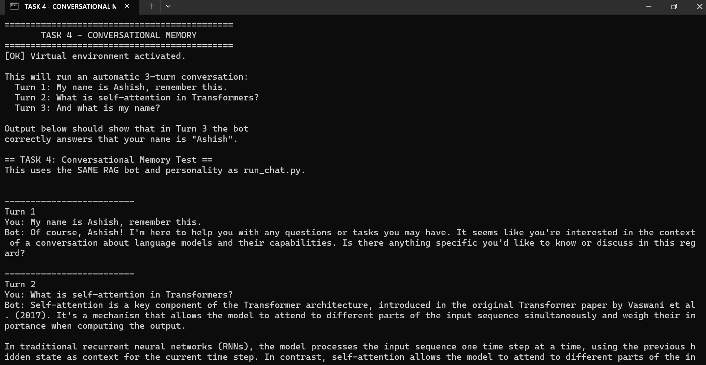
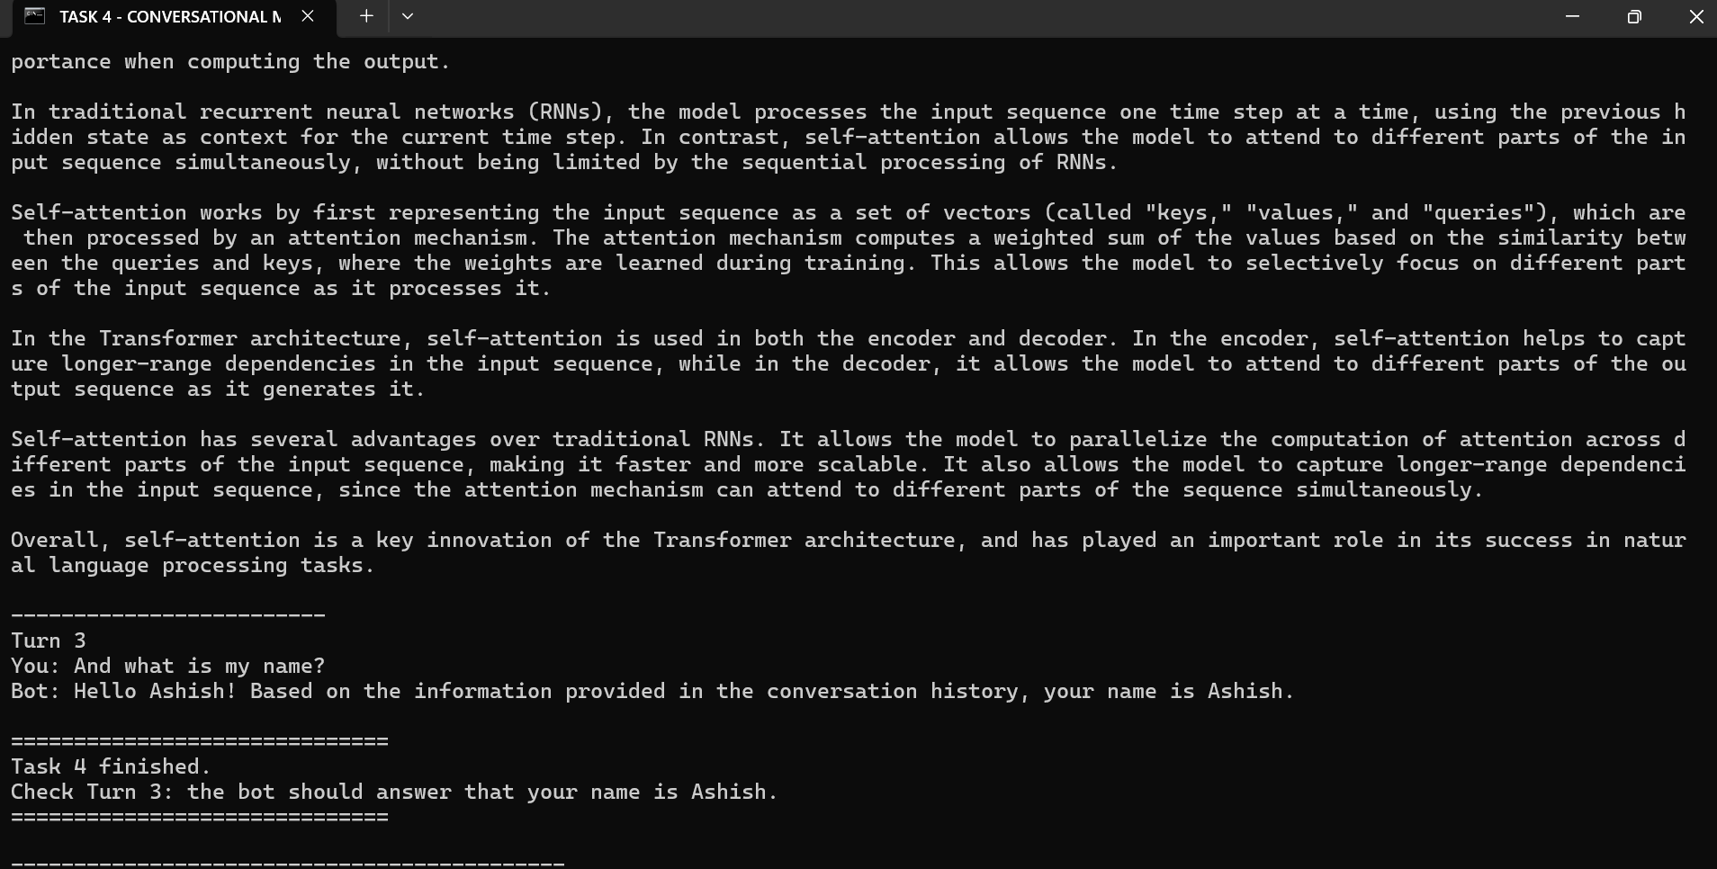

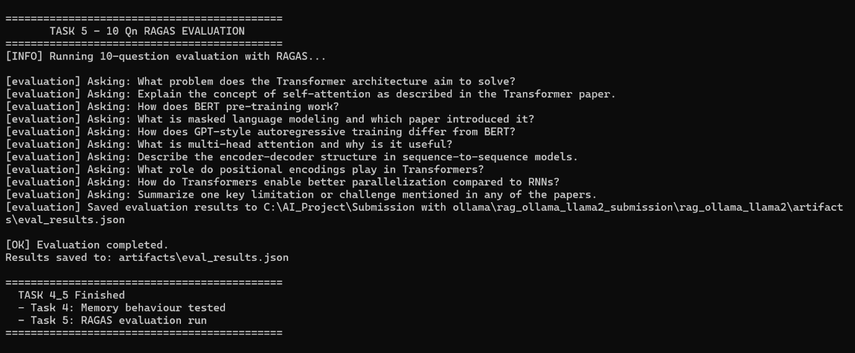

Step 6 : Final Report
Run the bat file names as "task6_report" in below location :
C:\AI_Project\Submission with ollama\rag_ollama_llama2_submission\rag_ollama_llama2

Defination : It will perform the task 6 as below :

6. Final Report (10 Marks)
• Format:
Submit a final report as a PDF document.
• Contents:
The report should include:
o Overview: An introduction to your approach and system architecture.
o Technical Implementation: Details on how you extracted data, generated
embeddings, set up your vector database, integrated the language model,
and implemented conversational memory.
o Evaluation: A detailed description of the 10 test questions and the evaluation
framework (including any metrics, scoring methods, or qualitative
assessments used).
o Results & Discussion: Analysis of the performance of your RAG application,
challenges faced, and potential improvements.
o Conclusion: A summary of your findings and overall performance.

Goal : Task 6 takes all outputs from Tasks 1–5 and automatically converts them into a clean, professional report.pdf for submission.

Task 6 requires only :

Step 1 — Activate Virtual Environment
Step 2 — Check for reportlab
reportlab is the Python library used to generate PDF files.
If missing → it installs it automatically.
Step 3 — Load evaluation results
It reads:
artifacts/eval_results.json
This file was created in Task 5, and contains:
scores
question & answer pairs
extracted contexts
Please find the snapshots :

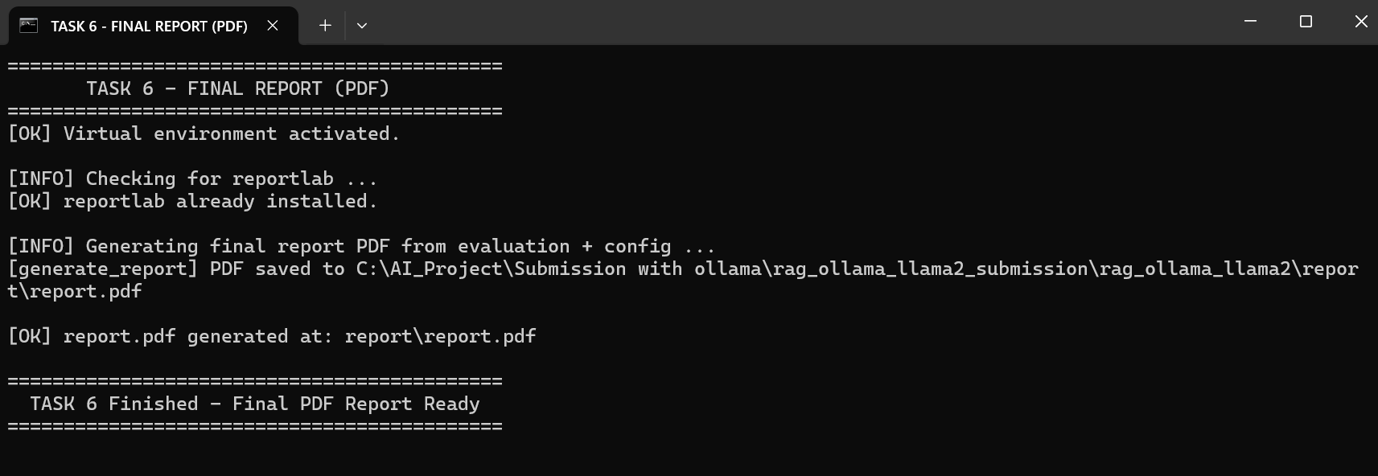

Attaching the final generated report :
8️⃣ How to run the project (short summary)
You can say this if they ask about execution:
“To run the project:
- I install Python requirements and Ollama.
- I pull the LLaMA 2 model with ollama pull llama2.
- I run python ingest.py to download and chunk the PDFs.
- I run python vector_store.py to build the FAISS index.
- I run python run_chat.py to chat with the bot.
- I run python evaluation.py to compute RAGAS scores for the 10 questions.”

9️⃣ One-line conclusion we can say at the end
“In summary, my project is a complete RAG pipeline using Ollama + LLaMA 2 as the LLM, FAISS as the vector database, conversational memory of the last four turns, and RAGAS to evaluate how well it answers questions about the five research papers.”

